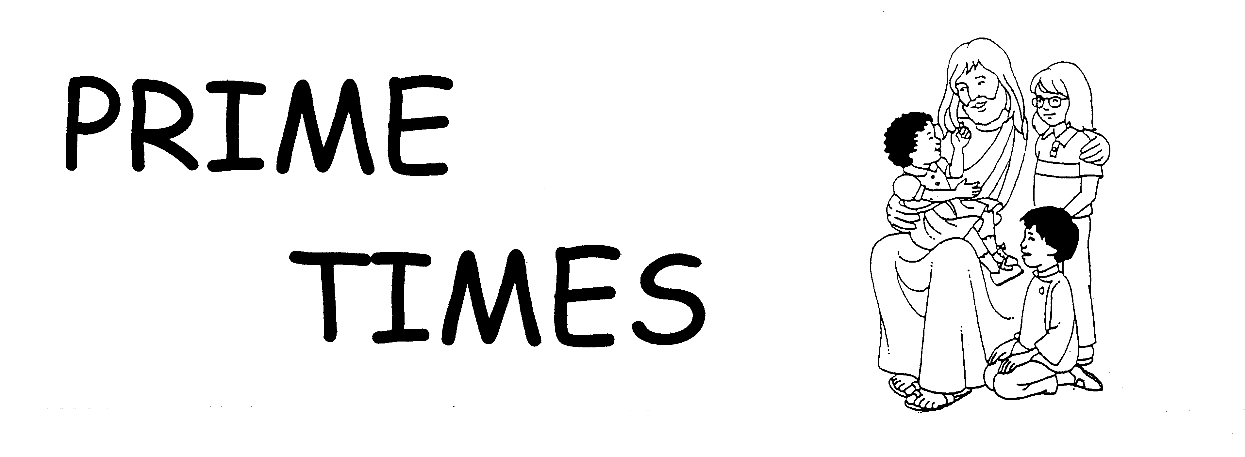

Sisters, Servants of the Immaculate Heart of Mary
Immaculata, Pennsylvania 19345 August, 2015

New School Year Prayer:
Dear Lord,
Another school year is about to begin.
Please give me the grace to stop and
SEE what lies ahead with new eyes
HEAR what my students truly need
TASTE the joy of small accomplishments
SMELL the sweet scent of young minds blossoming and finally, dear Lord, help me to
TOUCH their hearts with Your love.
Amen

Guardian Angel Poem:
My Guardian Angel
I have a little angel
Who walks with me each day
And keeps me safe from danger when
I go outside to play.

My angel never leaves me
Is always at my side
When I don't know just what to do
My angel is my guide.

My angel watches over me
I'm never out of sight
Guards me and protects me
Every day and every night.

Morning Offering
To the tune of "Twinkle, Twinkle, Little Star"

I will show my love in all
things I do both great and small,
all I think and do and say,
when I work and when I play.
I will show my love in all
things I do both great and small.

New Beginnings
To the tune of "Clementine"

New beginnings, new beginnings,
New beginnings come for me.
I am going soon to _________ grade.

I'll be happy, I'll be happy,
I'll be happy in __________ grade.
I will learn so many new things.
You will see the things I've made.

Thank You, dear God. Thank You, dear God.
Thank You, God, for all you share.
Thank You for my new beginnings.
Thank You for Your loving care.

Weekend Report

To encourage reading, writing, and public speaking introduce a class mascot (a stuffed animal of some kind) to your classroom. Every Friday a name is drawn from a bucket to find out who gets to take the class mascot home along with the class journal. Over the weekend the student will document what he/she does with the mascot in the class journal. Pictures can be drawn or glued in under the written entry. On Monday morning the student will share his/her adventures with the class.

Lining Up for the Hall Transition Poem
Wiggle - by Nicole Ricca

I have a little wiggle deep inside of me
I tried to make it stop,
but it wouldn't let me be,
I pulled out that wiggle
and threw it like a ball.
And now (teacher's name) knows,
I'm ready for the hall

Birthday Chart


A new twist on a classroom staple. When designing your classroom birthday chart this year ask parents to send in or email a picture of their child as a baby. Then you can glue the picture with the child's name in his/her birthday month. This is also a great idea if you have a Baptismal Birthday Chart in your classroom. Same idea, however, the picture would be from their baptism.

A Family Prayer before the First Day of School

Parent: School starts tomorrow, Mary. We put this year in your hands.
Second parent: We pray that our family will emerge in June more learned, more prayerful, and more compassionate to others.
Child: For my new teacher, ____________, that she [he] will like me and I will like her [him] and that I will learn all that I am supposed to learn in __th grade.
All: Please pray to Jesus for us, Mary. (Each child in the family repeats this particular prayer.)
Parent: That all children everywhere will experience loving teachers and good classes.
All: Please pray to Jesus for us, Mary.
Child: That my school year will be filled with good classes, good friends, exciting school activities and God’s love.
All: Please pray to Jesus for us, Mary.
Parent: That we have a minimum of illness, missed homework, and missed busses.
All: Please pray to Jesus for us, Mary.
Parent: That our children will help new children to be less lonely and less frightened these first days of school.
All: Please pray to Jesus for us, Mary.
All: Hail Mary, full of grace, hear our prayer for a school year that will please your Son, educate us, and help us to fulfill God’s plan for us in His world. Amen.

By: Dolores Curran. Family Prayer/The Complete Guide for Praying Families. West Mystic, CT, Twenty-third Publications. 1978.

A snappy line-up tune
Tune: I’ve Been Working on the Railroad

I am ready for the hallway.
My hands are at my side.
I am ready for the hallway.
The teacher is my guide.
My hands and feet are very quiet.
My lips are silent too.
I am ready for the hallway.
I’ll be quiet till we’re through.

Just a dot!


Here’s a simple way to help students learn to use squeeze bottles of glue. Give each student a half sheet of black paper and have them attach white hole reinforcements on the paper. Then provide squeeze bottles of white or tinted glue. Encourage each student to put a dot of glue in the center of each hole reminding them to gently squeeze the bottle to control the amount of glue that comes out.

Tools for Spacing

Large paper clips, clothes pins, or popsicle sticks are great tools for teaching young students appropriate spacing. You can decorate the top of the stick with a laminated sticker or even the student’s picture. The student puts the vertical object after a word and writes the next word and then moves it to the next space.

Thanks for Popping In

When you know you are going to need a substitute, leave a token of appreciation with your plans and materials. Tape onto a bag of microwave popcorn a note that reads “Thanks for popping in!” It’s an easy way to show the substitute that you are thankful for their help. You may want to keep a supply on hand in a special place. Assign a student to place the popcorn bag on the desk, if you are absent unexpectedly.

Details, Please!


For this activity you will need a soft object to throw. Start with a three word sentence such as “The dog jumped.” Once you state the sentence toss the soft object to a student. The student holding the object repeats the sentence. Next the student adds a detail to the sentence and says the revised sentence out loud. Example: The big dog jumped. Then the student tosses the object to another student and that student repeats the revised sentence and adds another detail to the sentence. Continue until several different students have added details to the sentence. Then introduce a new three-word sentence. Wow! Where did the time go?

Columbus Day Song
To the tune of "Farmer InThe Dell"

In 1492,
In 1492,
Columbus sailed across the sea,
In 1492.

For 70 days he sailed,
For 70 days he sailed,
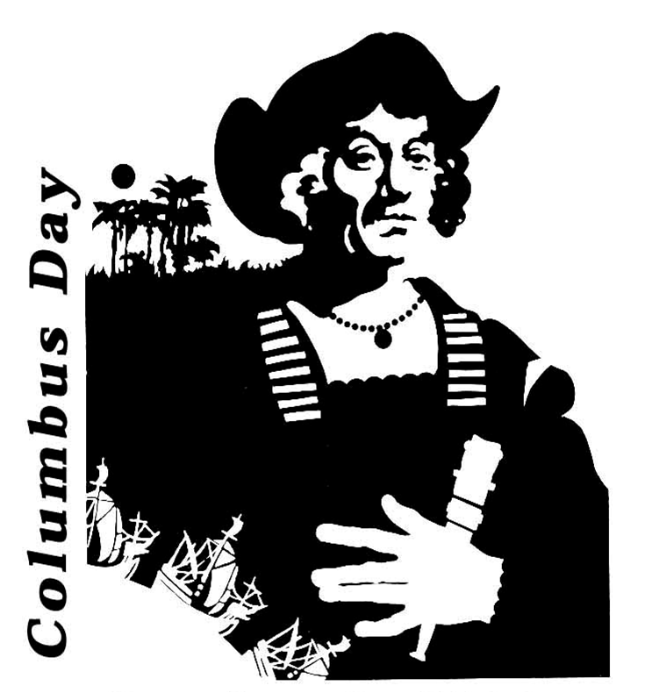
Columbus sailed across the sea,
For 70 days he sailed.

He came to a new land,
He came to a new land,
Columbus sailed across the sea,
And came to a new land.

Exploring he did go,
Exploring he did go,
Columbus sailed across the sea,

Exploring he did go.

He sailed back home to Spain,
He sailed back home to Spain,
Columbus sailed across the sea,
Then sailed back home to Spain.

Journal Topics for October

How are candy apples and cotton candy alike? How are they different?
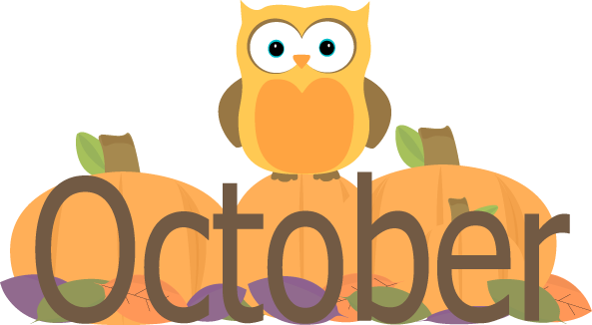

Would you be able to make your Halloween candy last until Christmas? Why or Why not.

Describe the kinds of treats you would like in your Halloween bag. What kinds would you not like and why?

Recycling Church Bulletins

Use leftover Church Bulletins to locate upper case and lower case letters, short and long vowel words, compound words, nouns, adjectives, and adverbs. Choose a different color crayon or marker for the skill you are reviewing. Each day highlight a different phonics skill. Have students use the designated crayon or marker to underline the skill of the day. Example: Use your green crayon/marker to underline upper case and lower case Mm. The next day: use your blue crayon/marker to underline short i words as in pin. This also works with flyers that are sent home. You may also need to demonstrate how to highlight.

Picture This

Using the same idea, gather a collection of colorful and appropriate pictures taken from outdated calendars. Store in a container assessable to students. During independent activities students can choose a picture and glue it the center of a blank sheet of paper. Then, around the picture, have students write adjectives that describe the picture. To extend the activity, have students write a sentence using one of the describing words or a short paragraph using some of the describing words.

Puzzle Stories

Stir creativity in reluctant writers by using puzzles. Purchase large piece puzzles with 24 or 28 pieces. Number the back of each puzzle with the same number. Place in a zip lock bag and number the bag with the same number that is on the puzzle. Have each student choose a bag and put the puzzle together then write two or three sentences about the picture. Older students can create a story about the picture. This same idea would work with laminated pictures that have been cut into puzzle shapes and number on the back as above.

Changes in Character

Open a window to an author’s underlying message with an examination of how the main character changes throughout the story. Have students fold a piece of theme tablet paper in half. In the middle of the first line on the left side print the main character’s name. On the left side second line print “In the beginning.” On the right side second line print “In the end.” On the left side students describe the actions and feelings of the character at the beginning of the story and then at the end. Invite students to share their writing and summarize how the character changes during the story. Further discussion might include questions such as the following: What change in character do you think most affects the other characters in the story? Why do you think the author changed the character’s actions or feelings?

On a Roll!

This activity reinforces addition, subtraction, and multiplication facts. Have students pair up. Give each pair a set of dice. Each student rolls a die. The students will add, subtract, or multiply the numbers on the dice. The first one who solves the problem gets to roll both dice. The activity continues for 3 or 4 minutes. Ring a bell or give a signal and students change partners and continue the activity from the beginning.

 Exploring WebQuests 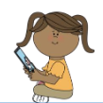

What is a WebQuest?

Students love WebQuests! Search for the word "WebQuest" in any search engine, and you soon discover thousands of online lessons created by teachers around the world. What is a WebQuest? A WebQuest is an inquiry-oriented online tool for learning. This means it is a classroom-based lesson in which most or all of the information that students explore and evaluate comes from the World Wide Web. Beyond that, WebQuests:
• can be as short as a single class period or as long as a month-long unit;
• usually (though not always) involve group work, with division of labor among students who take on specific roles or perspectives;
• are built around resources that are preselected by the teacher. Students spend their time USING information, not LOOKING for it. (Reference: 2004 Educational Broadcasting Corporation)

Parts of a Web Quest : Using PowerPoint, create a slide for each of the following:

Introduction: Sets the stage for the WebQuest. It creates interest in the activity, provides background information and foreshadows what is to come. Task: Describes what students are expected to do in terms of both process and product. The task should involve higher-order thinking skills and the transformation of information. It should be both doable and interesting. Process: Describes the steps that students should go through to accomplish the task. Because the steps of the process are clearly defined and provided in the WebQuest, teachers are able to access and implement ready-made WebQuests easily and effectively. Resources: A set of information resources that are needed to complete the task. Because resource materials are provided, students can focus on using information rather than on finding information. A variety of resources are included. Some resources may be Internet-based, including Web documents, experts available via E-mail, or e real-time conferencing and searchable databases on the Internet. Other resources may include books, magazines, newspapers, and CD-ROMs that are available in the classroom or school library. Evaluation: Identifies the criteria for evaluation, often through use of a rubric. This helps both students and teachers understand elements of the process and product through which students are expected to demonstrate their learning.
Conclusion: Brings closure to the WebQuest. It reminds students of what they’ve learned and can point them in new directions for further exploration and learning. (Reference: http://www.greenwichschools.org)

Resources to implement and sample WebQuests:
http://www.educationworld.com/a_tech/archives/webquest.shtml
http://www.teachersfirst.com/spectopics/webquest.cfm
http://eduscapes.com/tap/topic4.htm#2
http://www.teach-nology.com/teachers/lesson_plans/computing/web_quests/math/
http://www.teach-nology.com/web_tools/web_quest/
http://www.scholastic.com/browse/learn.jsp?grades=35

